**A PROJECT REPORT**

**ON**

**FRONT-END WEB DEVELOPMENT**

**“ RAISING AWARENESS ON COVID-19.”**

**BY**

**VARSHINI.G**

**ABSTRACT**

**Problem statement:**

**To Create a Multi –Page Responsive Website**

**Problem solution:**

**COVID-19 (corona virus) is a multi-page responsive website to raise awareness among people .**

**Which explains plethora of concepts like, how people are struggling due to pandemic, Symptoms of covid-19, Precautions to take care in this pandemic , how to get vaccinated , and a login and registration page to contribute for the poor in this hard times.**

**TABLE OF CONTENTS**

1. **Introduction………………………………………..3**
   1. **Problem Statement…………………………..4**
   2. **Project Objective……………………………..4**
2. **Existing Method……………………………………5**
3. **Proposed method with Architecture…….6**
4. **Methodology……………………………………….8**
5. **Implementation……………………………………8**
6. **Conclusion………………………………………….10**
7. **Introduction**

**COVID’19 has influenced many nations in a very little amount of time. The coronavirus has given a devastating blow to the entire world which is detrimental to the health condition of many people and continues to intimidate the world**

**1.1 Problem statement:**

**To Create a Multi –Page Responsive Website.**

**1.2 PROJECT OBJECTIVE:**

**COVID-19 (corona virus) is a multi-page responsive website to raise awareness among people .**

**Which explains plethora of concepts like, how people are struggling due to pandemic, Symptoms of covid-19, precautions to take care in this pandemic , how to get vaccinated , and a login and registration page to contribute for the poor in this hard times.**

**Achievements:**

1. **Awareness about corona.**
2. **Linking to the daily Statistics page about cases and deaths.**

**3. Linking to the vaccination registration page.**

**4. Collecting funds to help poor using a registration form.**

**2. EXISTING METHOD :**

**They are many referral websites about covid-19 to bring awareness .**

**They are few drawbacks too:**

1. **They are plethora websites where the end users get ambiguity problems, reduces readability.**
2. **Required content is not provided.**
3. **Indiviual websites for specific contents , increases scope of time.**
4. **PROPOSED METHOD WITH ARCHITECTURE:**

**This websites give you a package of contents.**

**It covers almost all the information, what is required for an viewer. Each different websites have specific contents , hence this website contains almost all the contents from Symptoms till the registration of vaccine and also about the pandemic and a contribute page too. So, this improoves readability, and there is no chance of ambiguity and it saves time for the viewer.**

**ARCHITECTURE OF WEBPAGE:**

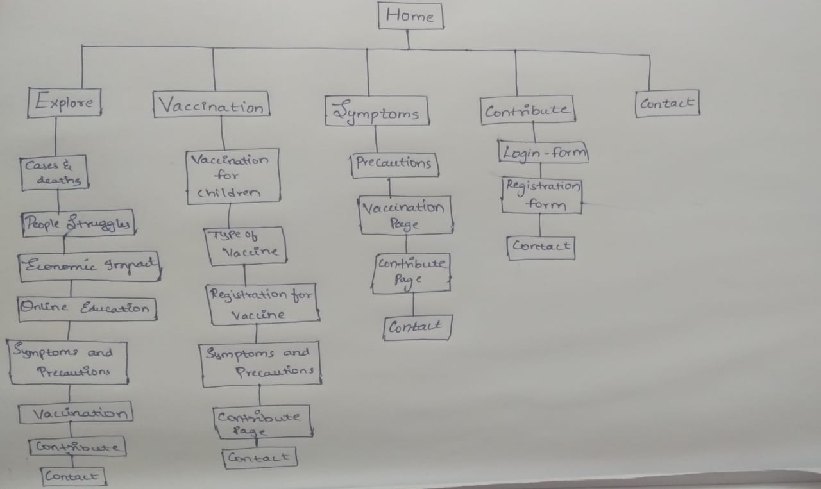

1. **METHODOLOGY:** 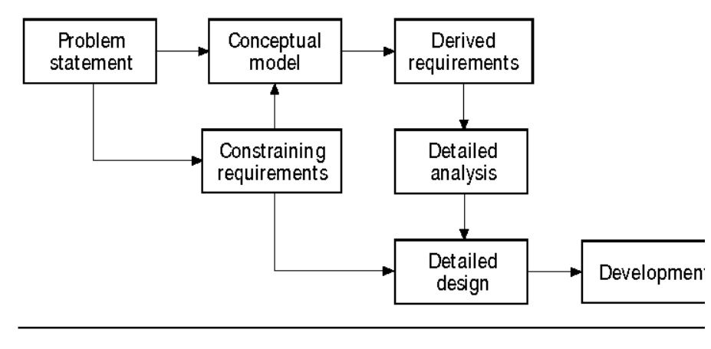
2. **Implementation:**

**Implementation is the process of building the web according to its design. A web implementor creates hypertext markup language (HTML), Cascading style sheets(css), and javascript.**

**The implementation process resembles software development because it involves using a specific syntax for encoding web structures or a programming language in a formal language in computer files. Although there are automated tools to help with the construction of HTML documents, a thorough grounding in HTML enriches the web implementor's expertise.**

**Key Implementation Practices:**

1. **At the outset, create an extendible directory and file structure to manage the web's files and css files.**
2. **Use HTML tools where helpful.**
3. **Check the web's implementation in various browsers.**
4. **web generating schemes for supporting a consistent look and feel.**

**Resources used:**

**Pixabay for images, Google fonts, font-awesome libraries**

**Visual studio code editor.**

1. **CONCLUSION**

**The purpose and objective of responsive multi-page website is achieved. By providing extremely rich designing in an anesthetic form. Flexibility in designing makes user to explore their imagination. And thus even a noicer user can dream and accomplish their wish for designing webpage.**

**Hence a Responsive Multi-web page design is done to raise awareness among people about covid-19.**